|  |
| --- |
| C:\Users\PHAMPH~1\AppData\Local\Temp\ksohtml\wps542E.tmp.png |
| Capstone Project Document |

**BAKERY STORE ONLINE**

Report #1 – Project Introduction

|  |  |  |
| --- | --- | --- |
| **Bakery Store** | | |
| **Group member** | Phạm Thị Minh Phương | SE03773 |
| Cao Anh Tuấn | SE03737 |
| Hoàng Anh Phương | SE03715 |
| Ngô Trung Kiên | SE03736 |
| Nguyễn Xuân Hà | SE03484 |
| **Supervisor** | Mr. Nguyễn Văn Sang | |
| **Project code** | BSO | |

**- Hanoi, 09/2017 –**

# SIGNATURE PAGE

AUTHOR: Phạm Thị Minh Phương 15/09/2017

Project manager

REVIEWERS: Cao Anh Tuấn 16/09/2017

Team member

APPROVAL: Nguyễn Văn Sang --/--/--17

Supervisor

Record of change

*A - Added M - Modified D – Deleted

|  |  |  |  |  |  |
| --- | --- | --- | --- | --- | --- |
| Effective Date | Changed Item | A,M,D | Change Description | Reason for Change | Rev. Number |
| 15/Sep/2017 | Create Introduction | A | Create Introduction | First version | 1.0 |
|  |  |  |  |  |  |
|  |  |  |  |  |  |
|  |  |  |  |  |  |
|  |  |  |  |  |  |
|  |  |  |  |  |  |
|  |  |  |  |  |  |
|  |  |  |  |  |  |
|  |  |  |  |  |  |
|  |  |  |  |  |  |
|  |  |  |  |  |  |
|  |  |  |  |  |  |
|  |  |  |  |  |  |
|  |  |  |  |  |  |
|  |  |  |  |  |  |
|  |  |  |  |  |  |
|  |  |  |  |  |  |
|  |  |  |  |  |  |
|  |  |  |  |  |  |
|  |  |  |  |  |  |
|  |  |  |  |  |  |
|  |  |  |  |  |  |
|  |  |  |  |  |  |
|  |  |  |  |  |  |

Contents

SIGNATURE PAGE

1 INTRODUCTION

1.1 Purpose

1.2 Acronyms and Definitions

2 ABSTRACT

3 LITERATURE REVIEW

4 PROPOSAL

4.1 The idea

4.2 Objectives

4.3 Brief description about system

4.4 System features

4.5 For our group

4.6 For Community

5 CRITICAL ASSUMPTION AND CONSTRAINTS

6 POTENTIAL RISKS

7 REFERENCES

# INTRODUCTION

## Purpose

This document is created as the introduction for project Bakery Store Online – our Capstone Project at FPT University. In this document, we will descript the overview of some existing systems, the initial idea for our project, a brief description about our expected system and some potential risks, critical assumptions, constrains. Moreover, this document also shows opportunities what it offers for users.

## Acronyms and Definitions

|  |  |
| --- | --- |
| Acronym & Abbreviation | Definition |
| BSO | Bakery Store Online |
| FU | FPT University |
| Q&A | Question and Answer |

**Table 1-1:** Definitions and Acronyms

# ABSTRACT

Bakery Store Online a standalone application which is based on ordering and selling the cake and other items and generating bill. The main principle behind the need of Bakery Store Online is easy supervision of shop. It has user friendly & modular approach. The modular approach of the software increases the flexibility of the software. Data storing is easier. It will be able to check any report at any time. Paper work and manual work is reduced. The system is user friendly and easy to use. The record of each customer is stored that is customer’s name and contact details are added for reference. Next the item is selected, flavours, pounds and quantity is also added. At the end of the day, report is generated to calculate the payment for each user in each day..

# LITERATURE REVIEW

There are quite a few major platform for Sales Online your project idea. However just have one Sales Online in Vietnam and that major platform just aim to project. For example: banhngotphap.vn, parisgateaux.vn,…

### Paris Gateaux

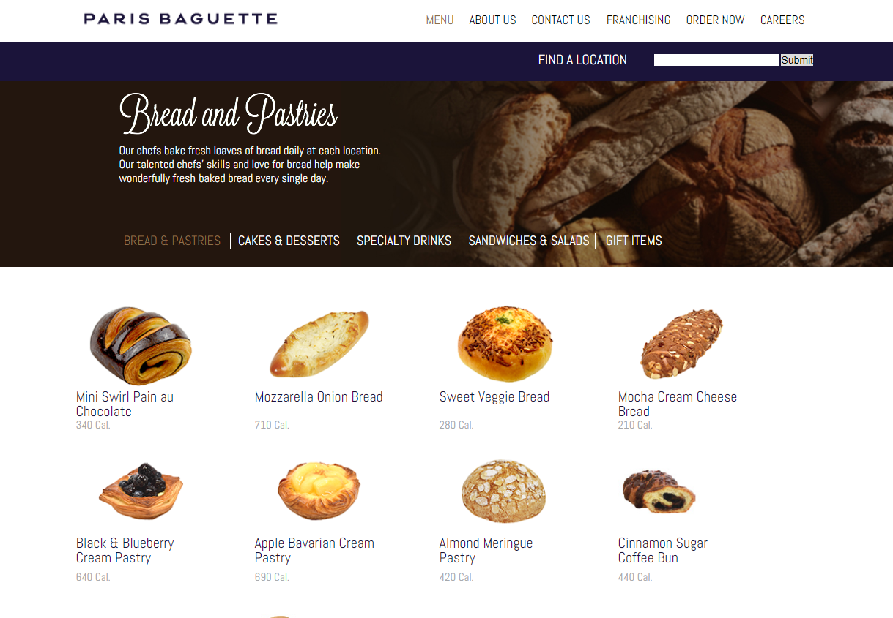

* Advantages:
* There are many different types of cakes
* Friendly site, easy to use
* Disadvantages:
* Can not see the price of the product
* Can not place order on website
* Not support online payment

### Madame Huong

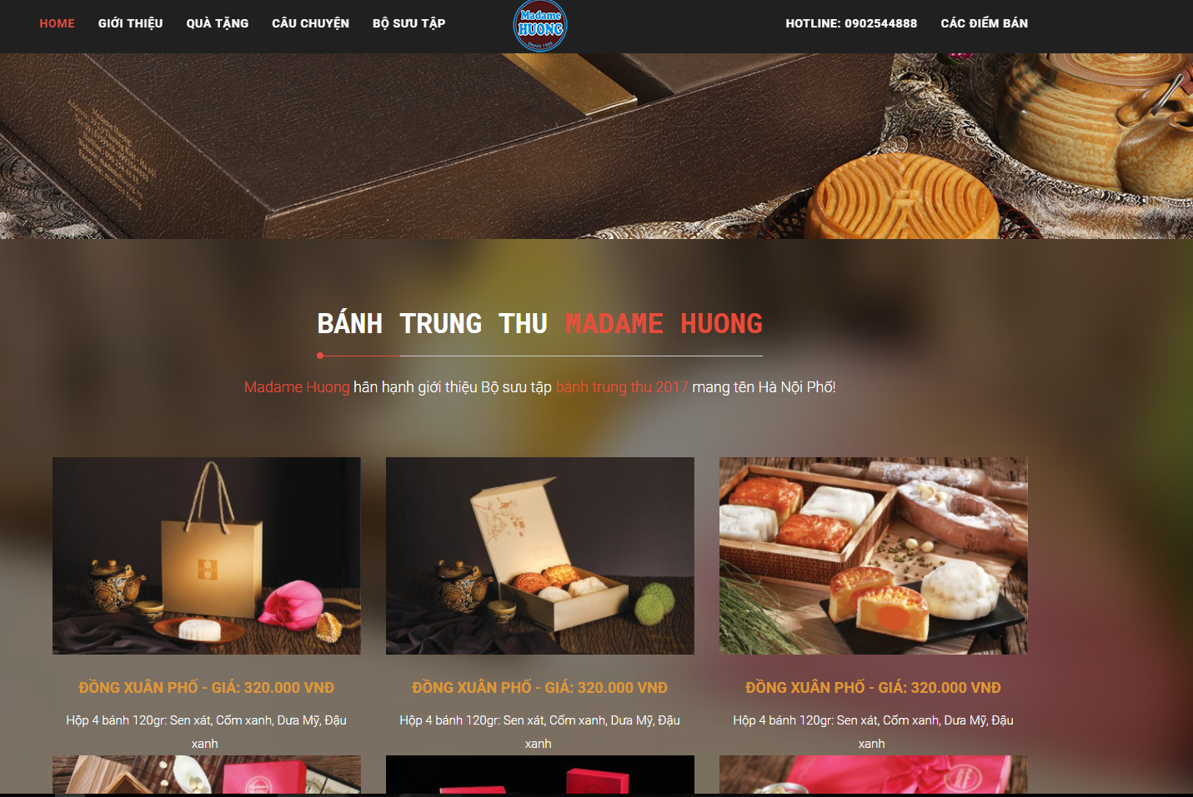

* Advantages:
* Friendly site, easy to use
* Can see the price of product in the website
* Disadvantages:
* Can not place order on website
* Only moon cake

 

# PROPOSAL

## The idea

## The need to enjoy delicious cakes is the constant need of every person, now we make our work become art, the more stimulated the demand is increasing. Society is growing thanks to the internet, we do not have to run out to buy bread.

## Bakery Store - is an online website that sells cakes. With a friendly interface and easy to use, anyone can buy the cake they need (for example, birthday cake, biscuits, diabetic cake ...). In addition, the site shares some simple recipes that people can reference and perform at home.

## Objectives

This project is the Capstone Project in FPT University studying the program.

This project is responsible for all team members. So, we must complete all requirements from teacher and FU. During 3 months of capstone project, we hope that all member can get more knowledge about processing of software development, skill do document, coding, testing. Moreover, soft skill also very important, we can get skill management time, working in group, skill communication… It is not long time for project but our group hope that can do this project successfully. This project also makes our CV more beautiful after graduating from FU. This is also an opportunity for us to prove capacity with recruiters.

## Brief description about system

This site will promote the business and increase the store's sales. With a friendly and attractive interface, users can easily find or reference the cake samples.

Bakery Store uses familiar technologies as: Bootstraps, MVC5, NodeJS… And we are planning to develop a mobile version for easily connecting.

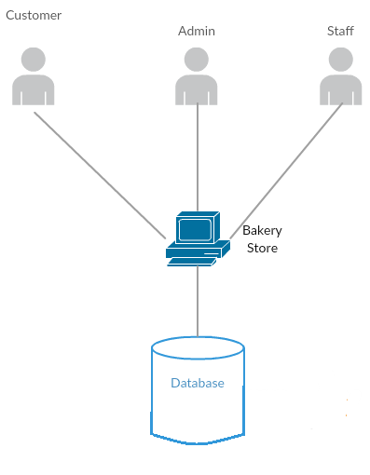

**Figure 1-3:** Brief descriptions diagram of Bakery Store system

## System features

About the features of Bakery Store, we focus to provide for users main features as searching, login, order, etc. Admin can manage users, manage staff, manage database, manage cake and manage blog.

In here, we focus on features which can help users can understand the best way what user want to have with features of Bakery Store. There are the detailed features of Bakery Store

### Client features

* Register: User can register an account and login to use all features of BS.
* Login/Logout: Users login/logout an account to use or exit system BS.
* Search: User can search with name of cake and system will display all of cake relate to keywords.
* Filter: User can filter with category (Introduce, Product, News, Service, Blog, Contact). And system will display projects relate to these selected options.
* Cake:
  + Shopping cart: after choose the cake and order, the cake will be in the cart.
  + View order history: after order success, user can review all the cake odered.
* Profile:
  + Change password: User can change password to keep security.
  + Update profile: User can change or update information.

### Admin features

* Login/Logout: Amin login/logout an account to use or exit system BS.
* Manage customer:
  + Search customer: Admin can search with name of customer and system will display simple information about that customer(name, email, phone number…)
  + Active/Deactivate user: admin can set customer’s account to active or deactivate.
* Manage staff:
  + Search staff: Admin can search with name of staff and system will display simple information about that staff(name, email, phone number…)
  + Active/Deactivate staff: admin can set staff’s account to active or deactivate.
* Manage cake:
  + Search cake: Admin can search with name of cake and system will display information about cake (name, size, cost,…)
  + Update cake: admin can change information about cake (name, size, number,…)
  + Add cake: admin can add new cake
  + Block cake: admin can block cake when it will not sale
  + Unblock cake: admin can unblock cake when it will sale
* Manage blog:
  + Search blog: Admin can search with title of blog and system will display blog
  + Add blog: admin can add new post
  + Block blog: admin can block blog
  + Update blog: admin can update blog
* Manage event:
  + Search event: Admin can search with title of event and system will display event
  + Add event: admin can add new event
  + Block event: admin can block event
  + Update event: admin can update event
* Manage category:
  + Search category: Admin can search with title of category and system will display category
  + Add category: admin can add new category
  + Block category: admin can block category
  + Update category: admin can update category
* Manage benefit:
  + Search by date: admin can search benefit by date of BS
  + Search by from date to date: admin can search benefit by from date to date of BS
  + View benefit: admin can view detail benefit of BS

### Staff features

* Login/Logout: Staff login/logout an account to use or exit system BS.
* Forgot pasword: when staff forgot their password to login the system, this function will receiving their password to email.
* Manage order:
  + Search order: staff can search order of staff
  + Confirm order: staff can confirm order transaction successful
  + Unconfirm order: staff can confirm order transaction unsuccessful
  + Cancel order: staff can cancel order of customer
* Update profile: staff can edit profile

## For our group

After developing and implementing this project, our group will get some benefits:

* Have more experiences of software project management how to manage plan, time, member and risk.
* Have more knowledge and skill about Node.js MVC5
* Know how to communicate with team members and how to teamwork more effective.

## For Community

Just need to have a device that connect to the internet and any web browser, user can:

* Easy buy cake
* Easy recieve cake

# CRITICAL ASSUMPTION AND CONSTRAINTS

* Critical assumption:
  + Training: All developers can train Node.js in 2 weeks. Before starting this project, just 1 member in our team have knowledge about Node.js, but with programming techniques which we studied at FU, we have to try the best to not missing any deadline in project plan.
  + Human resources: Assume that all members in team have a good healthy to do their tasks.
* Constraints:
  + Time and deadline: We must complete task on time. We work on 14 weeks, each member works 5 hours/day and 5 days/week. We do not have more time for us to complete developing and deliver application to teachers. Besides, we have to submit report documents before deadline to teacher can review.
  + Quality: The products must be run well when users perform main functions in Google Chrome 40 and Firefox 30 or higher.
  + Process: We have to follow the software processing of FPT Software
  + Human resources: There are 5 member in our team, each member have to study 2 subjects (Japanese and JFE) at school.

# POTENTIAL RISKS

After studying about this project, we find out some problem that we may be encountered:

* Under-estimate scope and time or miss deadline because lack of experience in group working, managing and controlling work.
* Loss data, source code before uploading data to server because of careless.
* Equipment got broken because of careless or accident.
* Human resources: Team member cannot complete their works because of health reasons, key member leave team or un-cooperating on team.
* Change requirements: Requirement changed when some functions cannot be completed or some technologies is not suitable.

# REFERENCES

* **Banhngotphap at URL:**  http://banhngotphap.vn/
* **Tous les jour at URL:** http://parisgateaux.vn/